How to Use ToonBoom Harmony
The Basics
By: Jessica Ordaz
- Upon opening the program, you’ll be greeted with this intro screen. Here, you’ll be able to name your project, choose where you want it saved, and figure out the size of the canvas, as well as the frames per second. Everything already filled in is default, which you can leave, just name your project on NAME and choose where it will be saved in LOCATION.
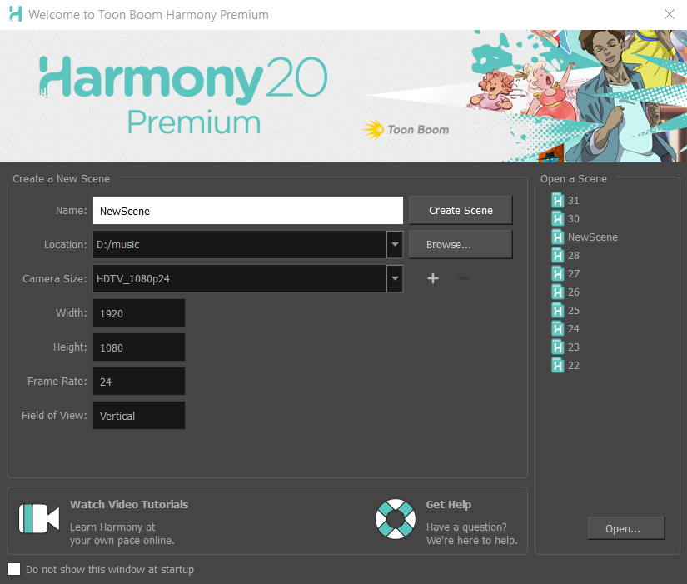

- After clicking Create Scene, you’ll be shown your main canvas! The first thing you need to do is add a colour card. A coulour card is a blank canvas that you can draw on. Click this + button and then click on Colour-Card.
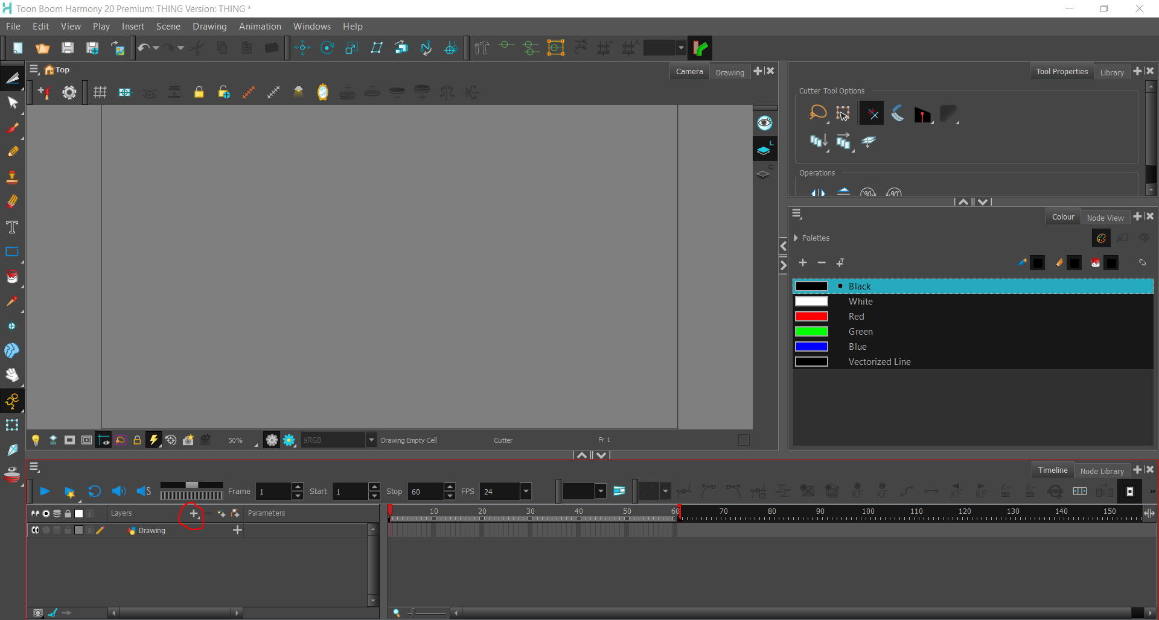
  - This section is your timeline, it will show all of the drawings you have made for every frame you draw.
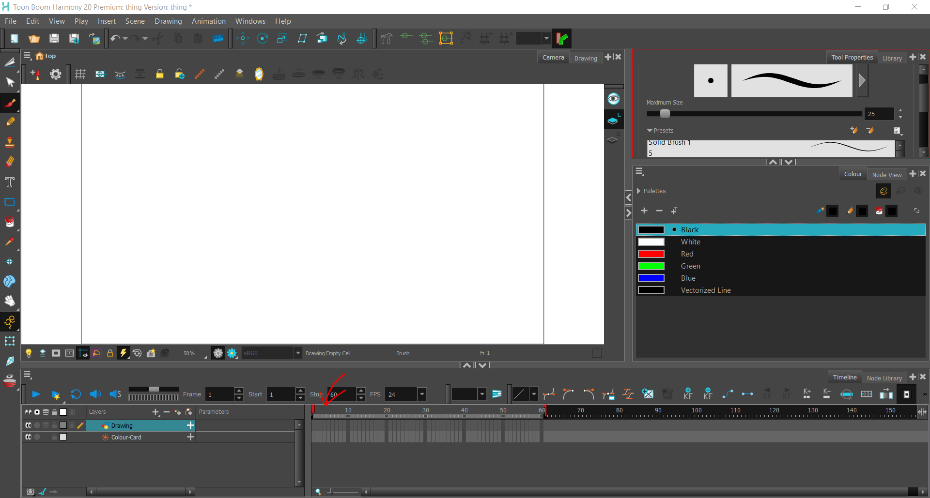
  - These tools with arrows are the tools you will be using the most. The top tool cuts out a drawing and lets you resize the drawing you selected, the paintbrush tool is to draw, your eraser tool erases whatever is on canvas, the T tool lets you put words on the canvas, and the hand tool lets you move your canvas around.
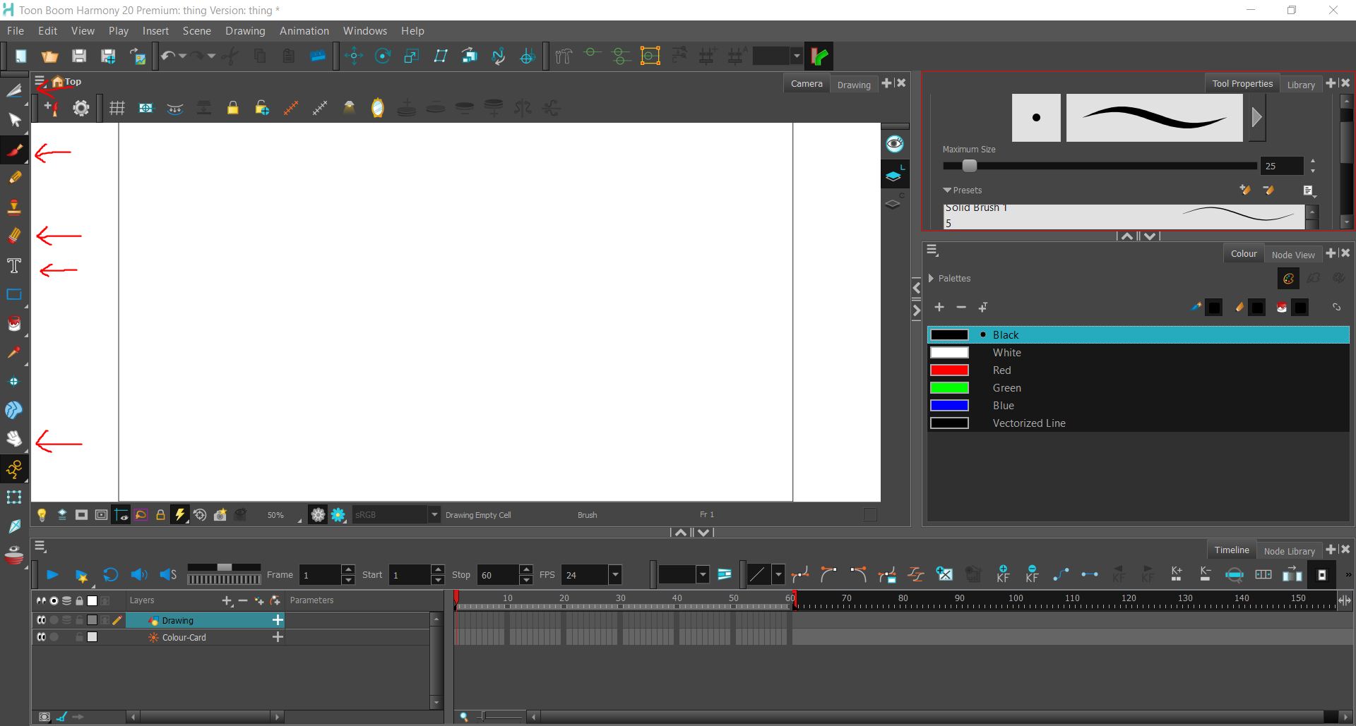
  - To zoom in and out of your canvas, click this button and select a percentage of zoom.
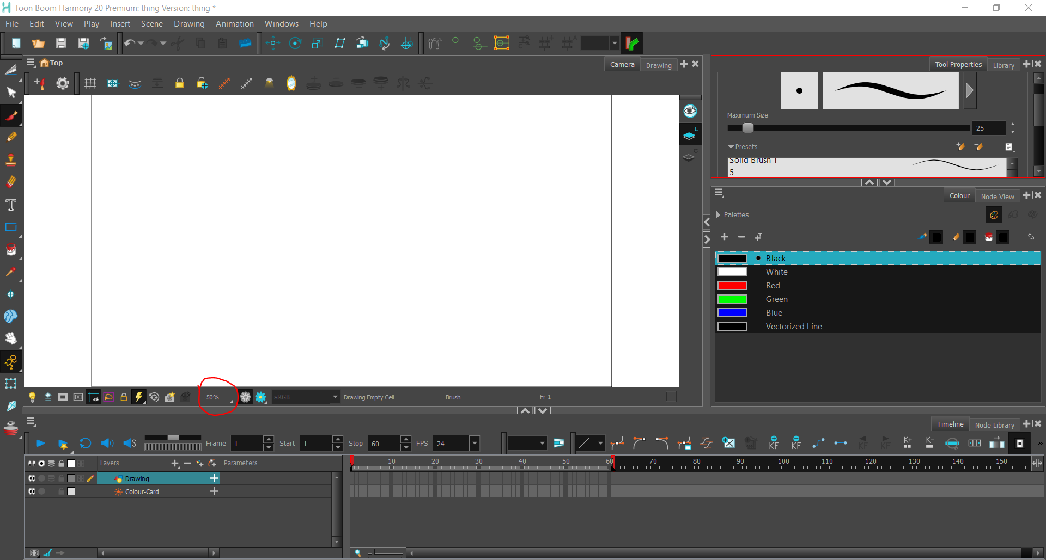
  - On the right side of the screen, you will find different kinds of brushes to draw with, including some that look like pencils and others that look like ink pens. There’s a lot of options! You can add colors with the + sign and change the size of your brush here too.
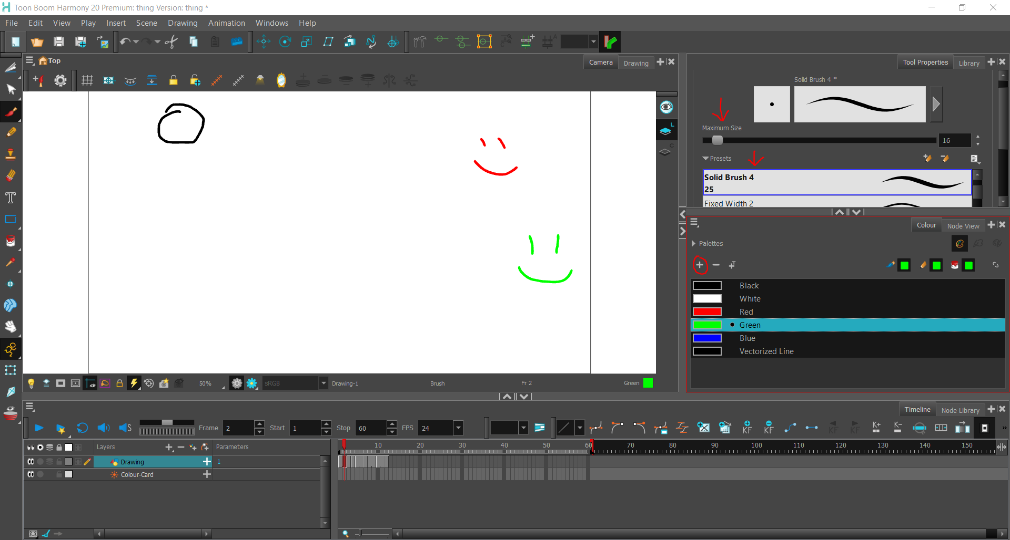
- Now let’s say you want to add frames to your animation. You can do that by clicking on the next empty frame or frames and then drawing on your canvas.
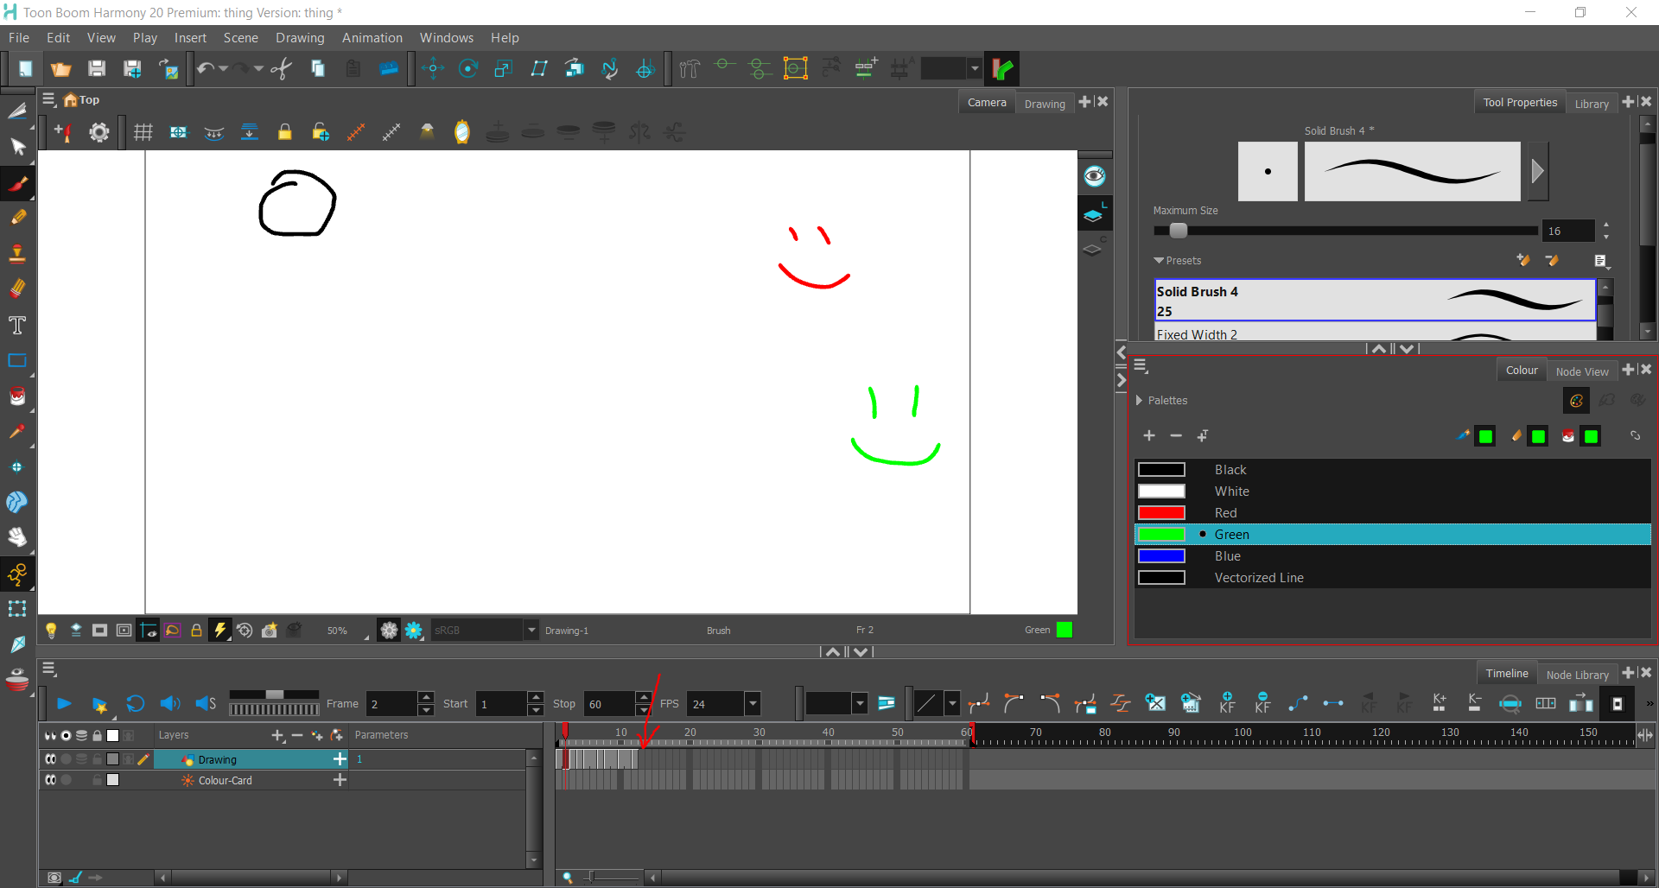
- Onion skins are important. An onion skin is a feature that allows you to see what the next frame looks like (in green) and what the previous frame looks like (in red) that you have drawn. You can turn onion skins on and off using this button.
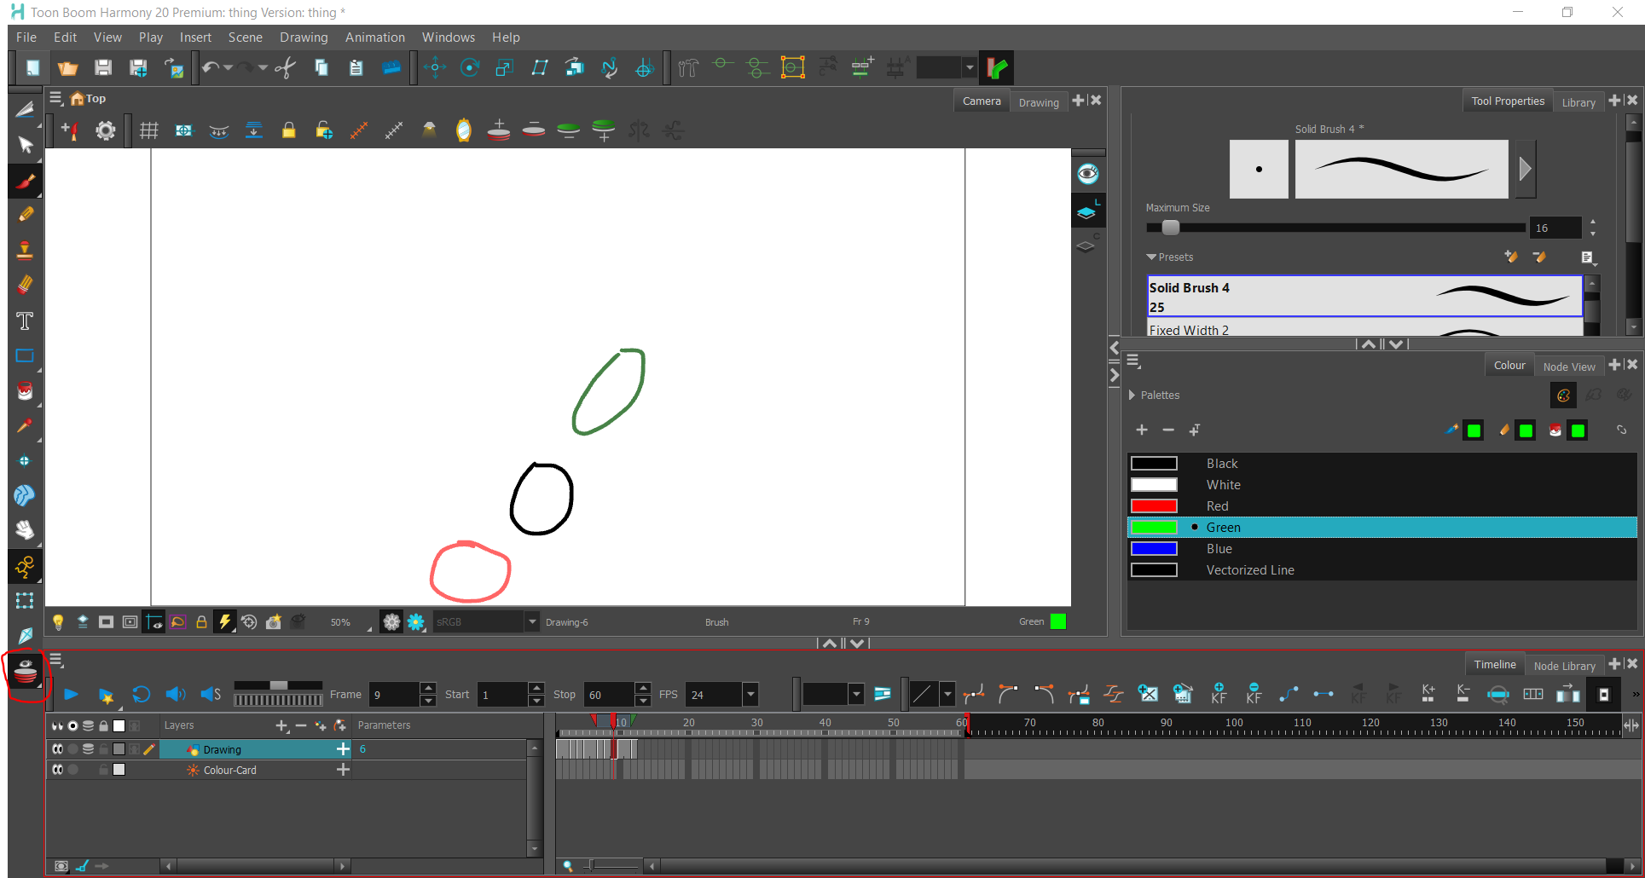
- Now let’s say you have a lot of frames! You can scroll between all the frames by dragging this bar to the left and to the right.
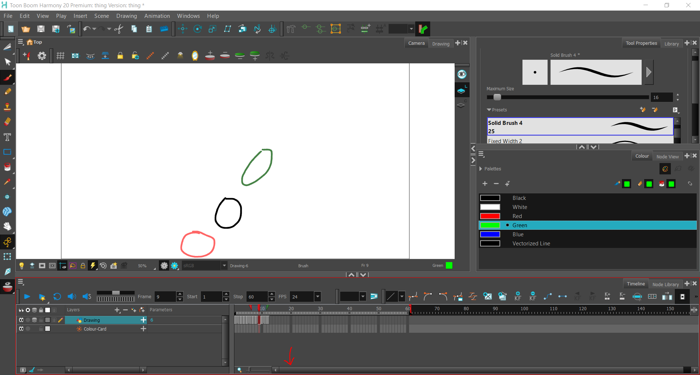

- Something important to remember is that while animating, 24 frames equals one second of animation. ToonBoom Harmony displays the number of frames you have here. To extend how many frames you can have, drag this red bar.
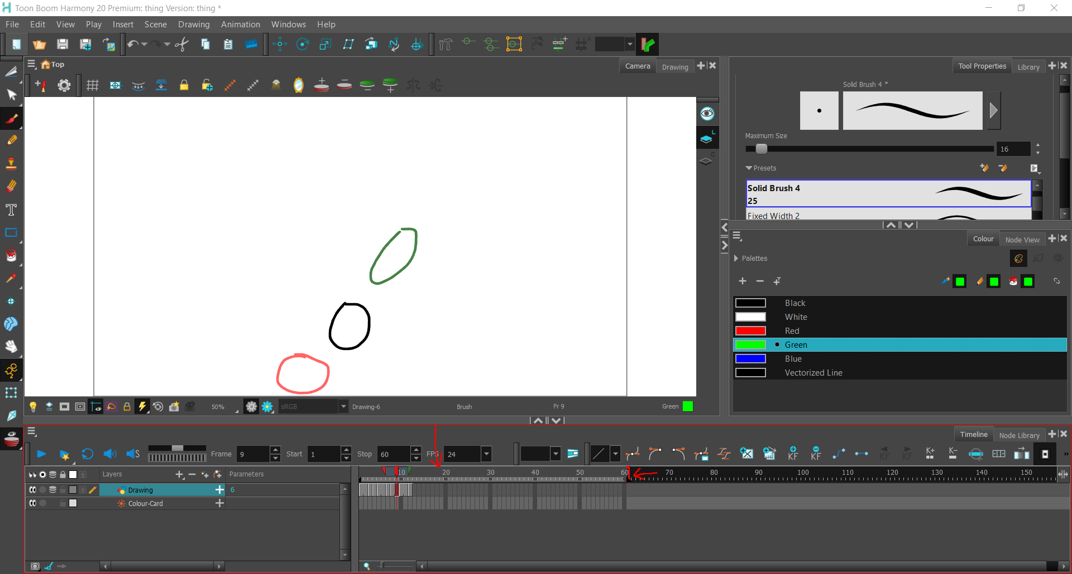
- If you want to play your animation to see how it looks, press this blue play button!
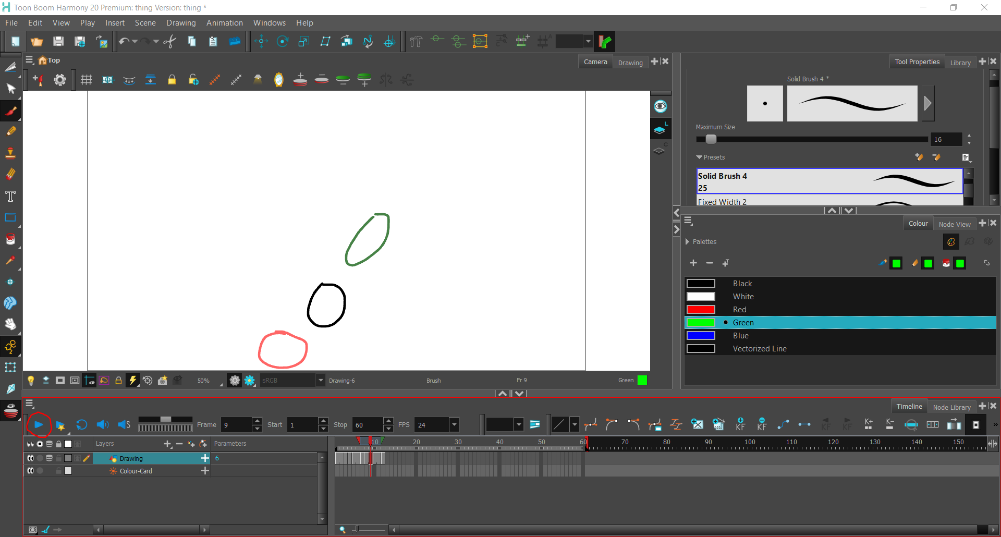

- Don’t forget to save your work as you go using this button!
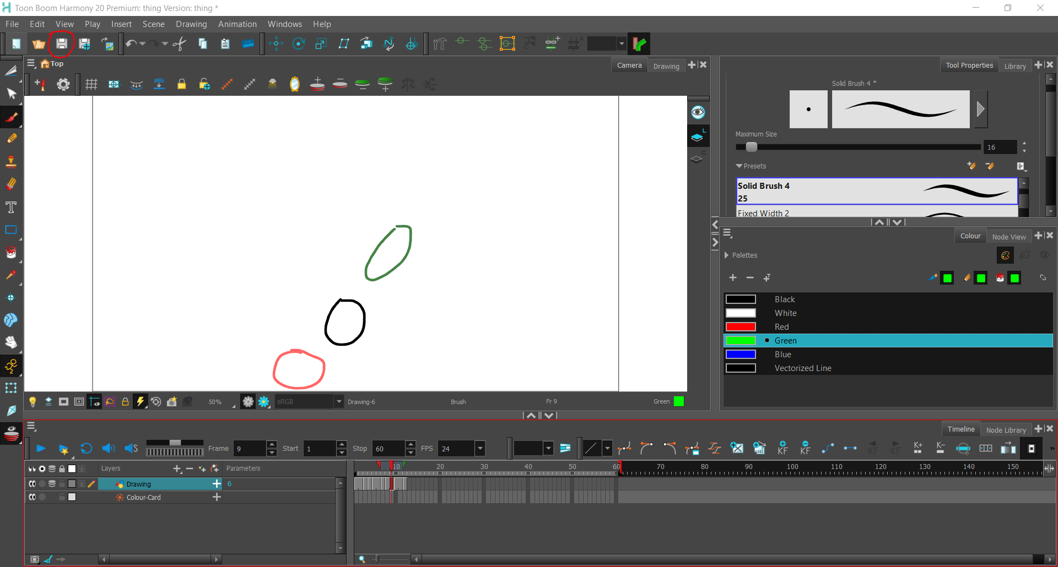
- You can add more drawing layers if you want to have multiple drawings animated at different times. To do so, click the + button and then click Drawing. To get rid of a layer, click the – button.
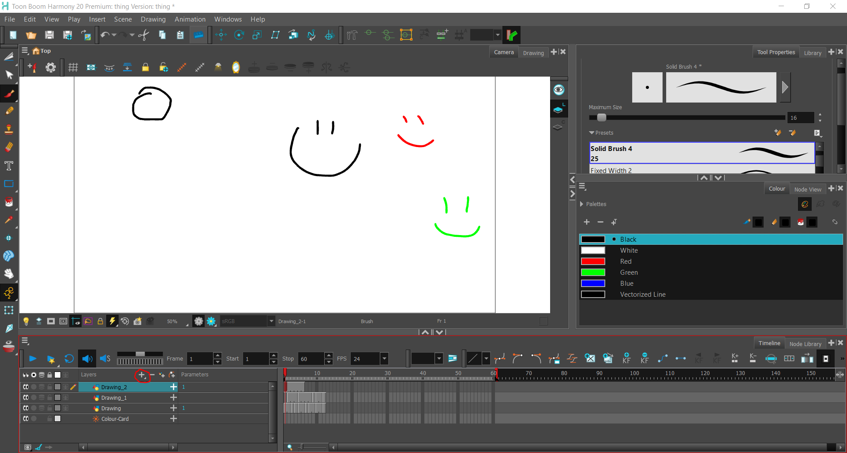

- To export your animation as a video, click on File, then Export, and then Movie. On this screen, all you have to worry about is picking where you want your video to be saved and the name of it! Then you click export and the program will export a video.
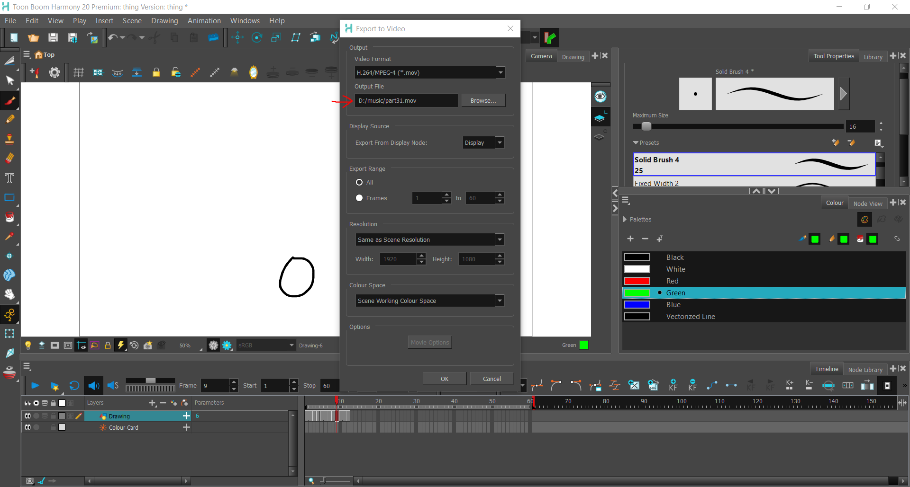

- One final note is that if you save and close your animation and want to return to it later on, you will need to open the folder it’s in and double click on this program file to open back up your animation.
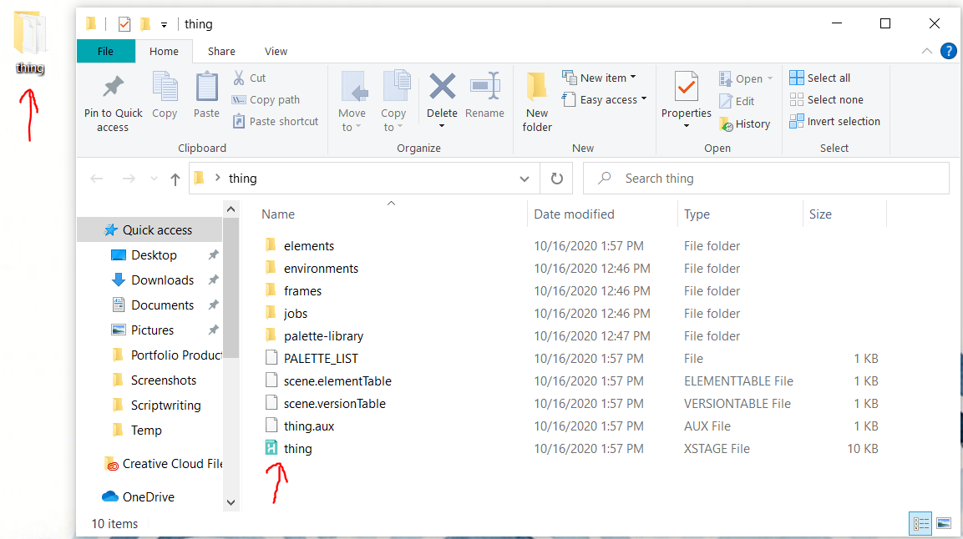
Congrats! You now know how to use the basics for ToonBoom Harmony!
Happy Animating!

